

**Βάσεις Δεδομένων 2021-2022**

**Αναφορά Εργασίας**

Διονύσιος Ρηγάτος – P3200262

Χριστόφορος Παπαποστόλου – P3150208

1. 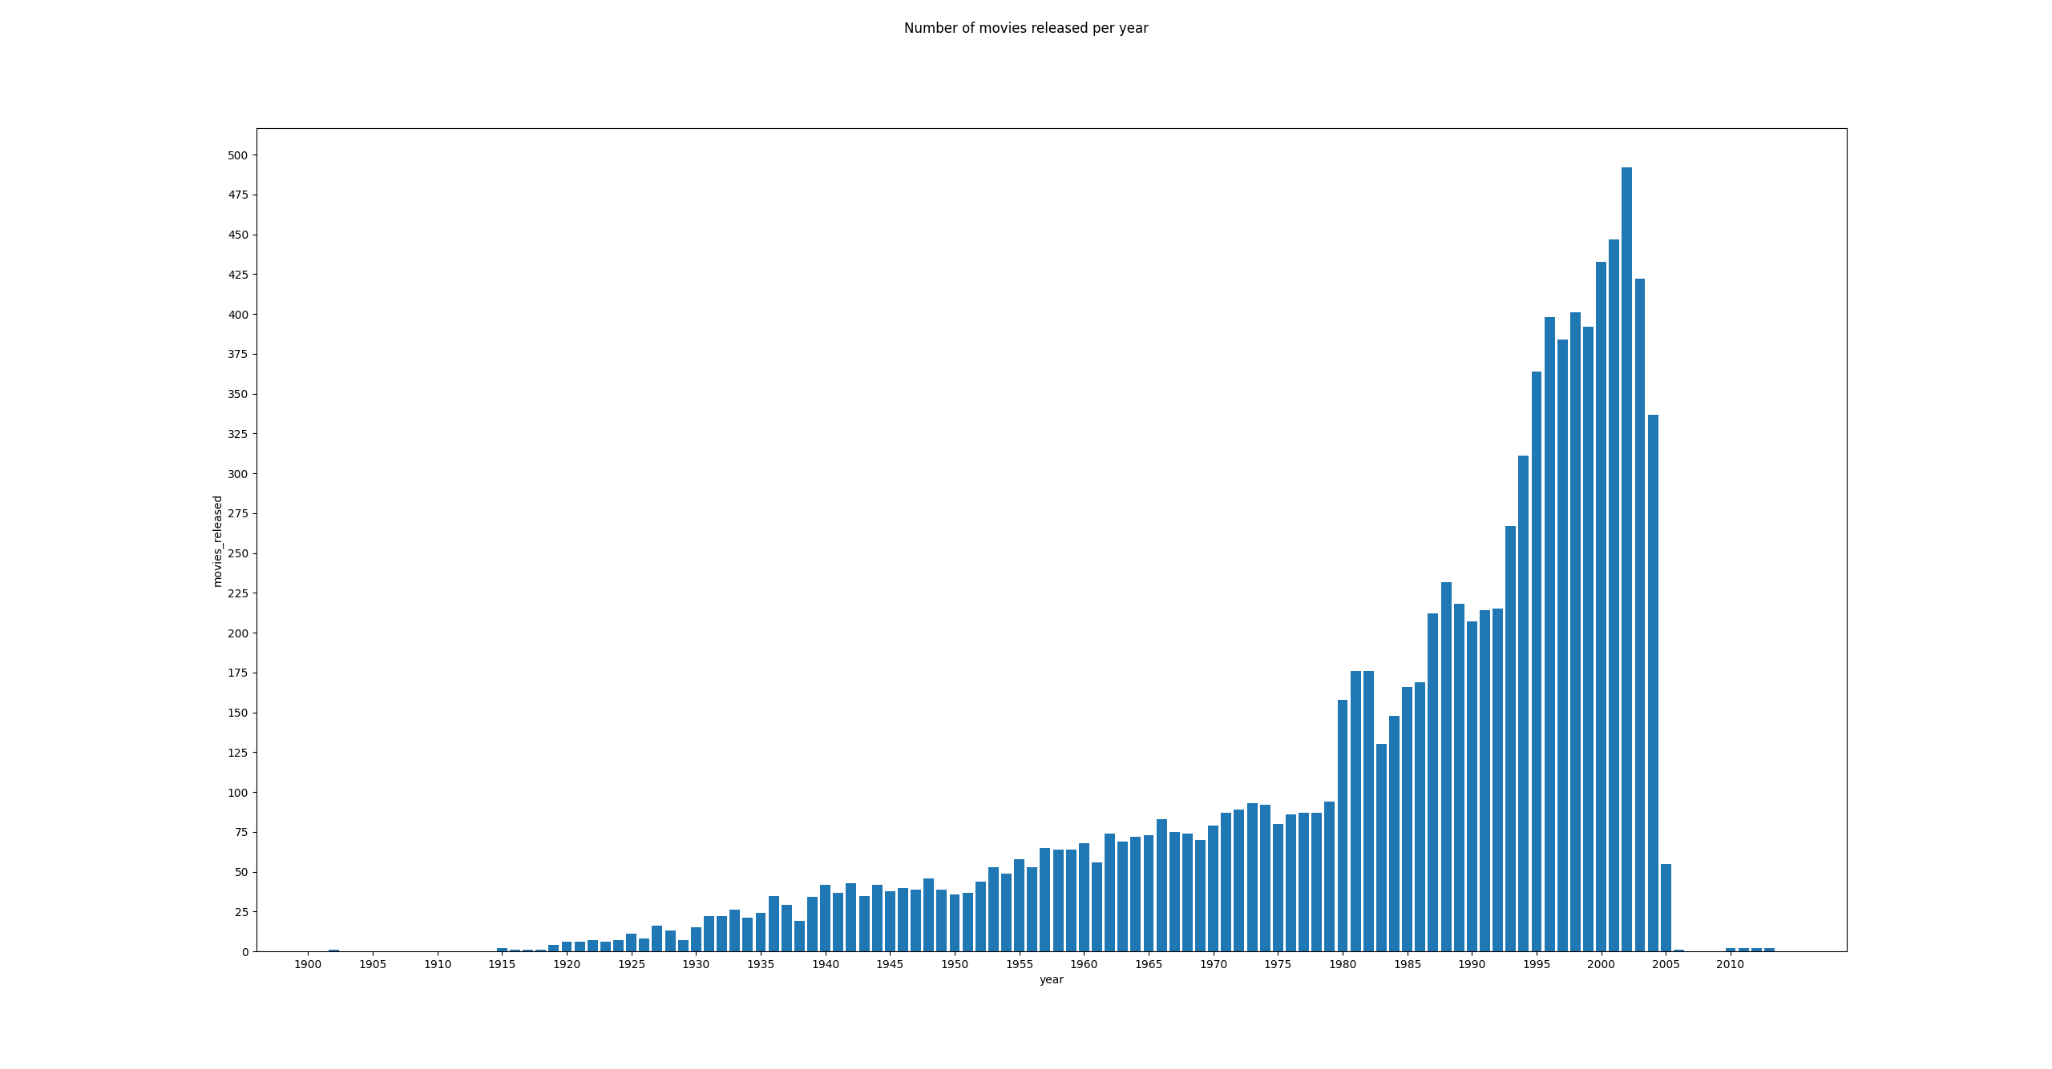Number of movies released per year – peak year being 2002
2. Amount of movies belonging to each genre – drama being the most common genre

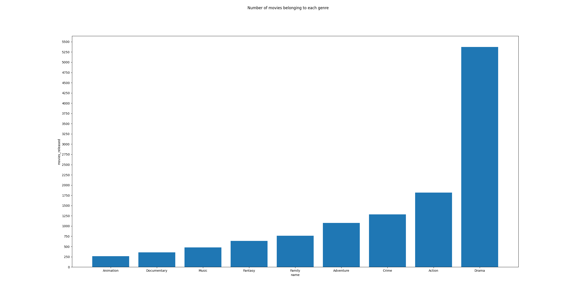

1. Number of movies per year, per genre

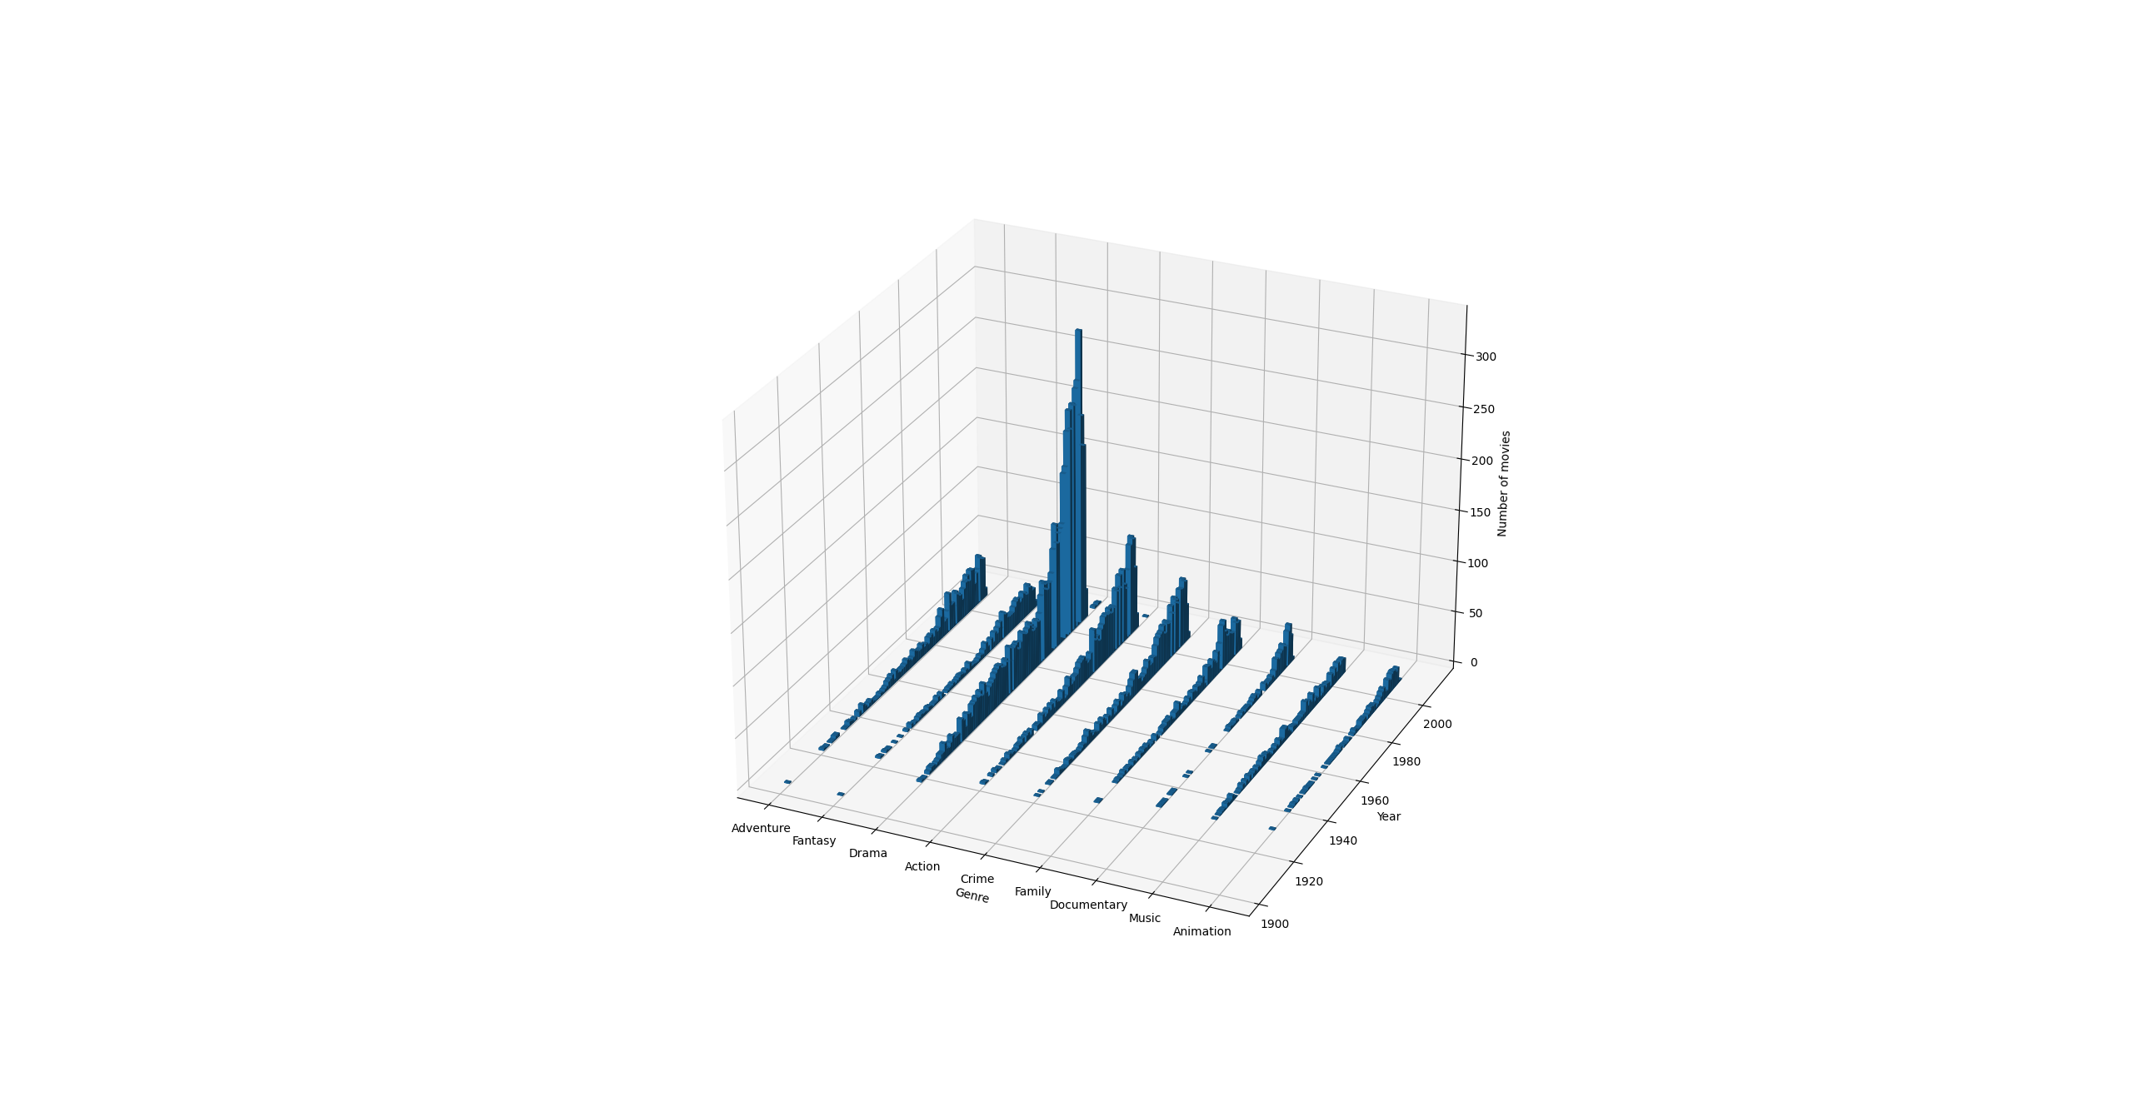

1. 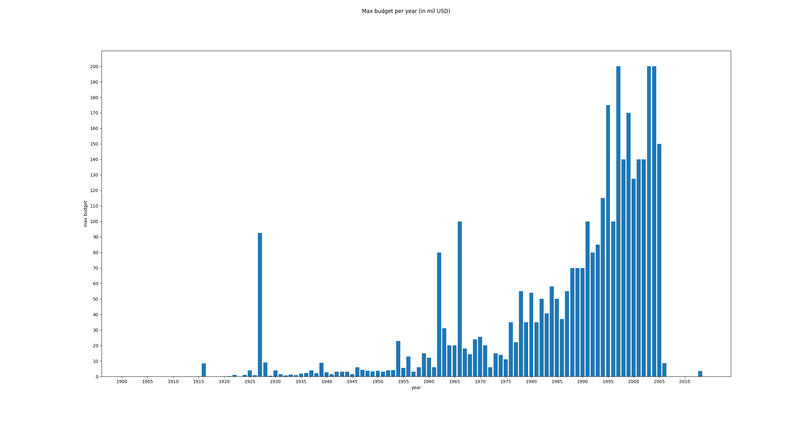Max Budget Per Year (in million USD)
2. 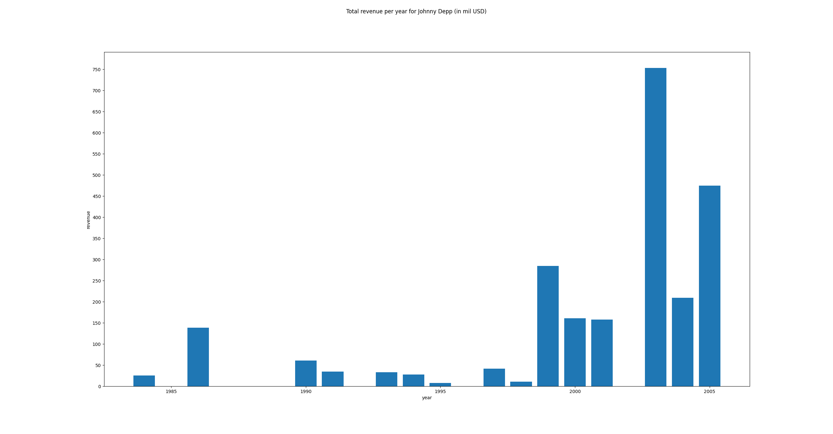Total Revenue per year for Johnny Depp (in million USD) – 2003 was the best year!
3. 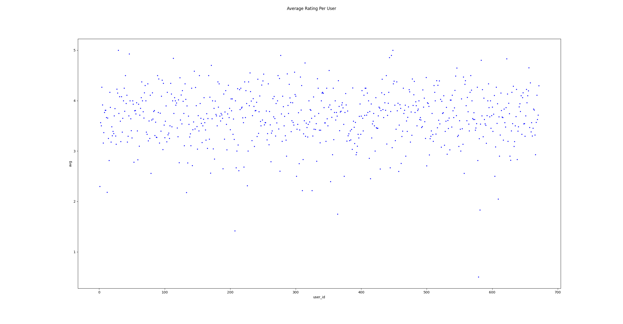Average Rating Per User
4. 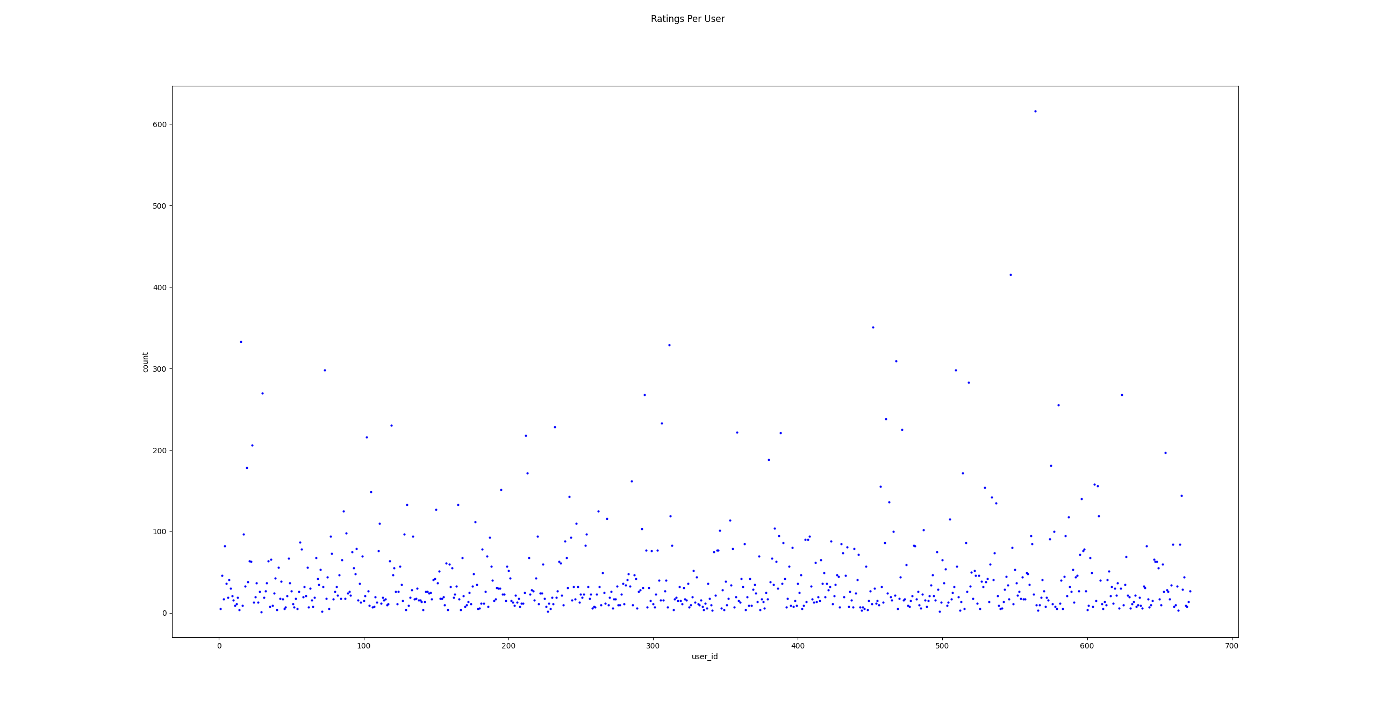Amount of ratings per user
5. 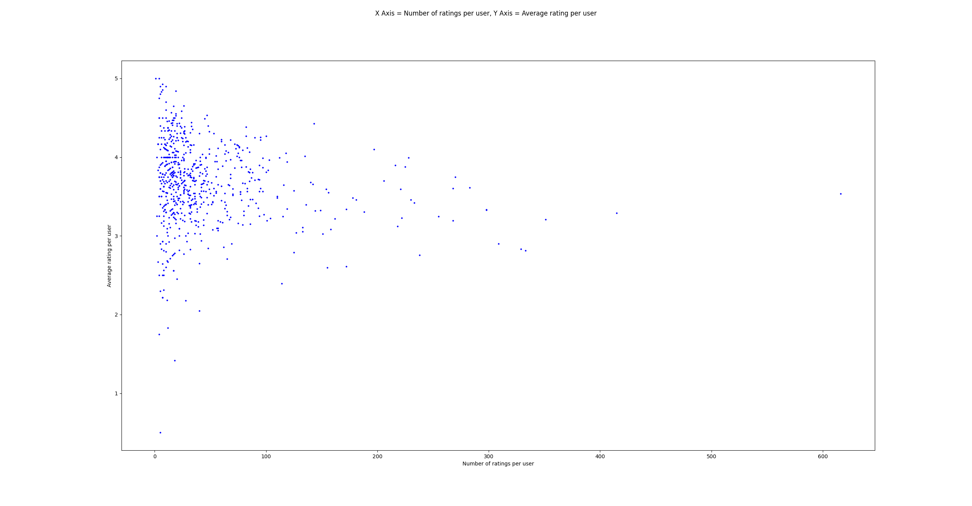\Average Rating Per User and Number of Ratings Per User PLOT
6. 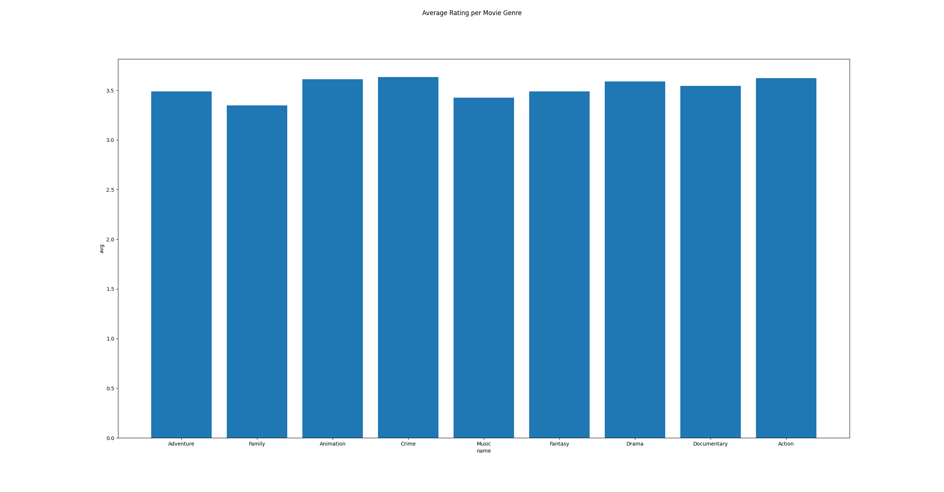Average rating per genre